Alverdiscott and Huntshaw Parish Council
Clerk: Alan Matthewman
26 Fairways View, High Bickington EX37 9BZ
01769 560740 07720 301894

Minutes of the Parish Annual General Meeting
And Annual Parish Meeting
Thursday 16th May 2025 at 7.00 pm in
The Village Hall, Alverdiscott

Members Present: Councillors Graham White (in chair), Bernard Hardwicke, Caroline Lewis, Jim White, Paul Matthews, Helen Bolton, Andy Reed
Alan Matthewman (Parish Clerk)

Members of the public are encouraged to attend.

1: The Chair declared the meeting open and handed the Chair over to Parish Clerk for Item 2 on the Agenda.

2: Election of Chair for 2025-26: The clerk asked for nominations to act as chair of the council for the coming year. There being no other nominations Cllr G. White, somewhat reluctantly on account of other pressures, agreed to serve in the capacity for another year. This was proposed by Cllr. J White, Seconded by Cllr Bolton and Approved Unanimously.

3: Clerk handed chair back to newly re-elected chair

4: Election of Vice-chair: Cllr G. White asked for any nominations for the position of vice-chair of the council. With some reluctance in view of his recent arrival on the council, Cllr Reed agreed to accept the position. He was duly proposed by G> White, seconded by Paul Matthews and elected unanimously.

3: Chair and Vice Chair sign Consent to Serve Forms: These were held over until the following meeting

4: External Reports

The chair read a report from the chair of the Alverdiscott Hall Committee – See Appendix A:

The chair read the report from the Local Rag – Appendix B

Cllr Lewis read the report from the Huntshaw Hall Committee – Appendix C

The meeting closed at 19.25

Councillor Graham White
Chair of the Parish Council
12th May 2025

Next meetings will be May 2026 at date and time to be decided

Appendix A:

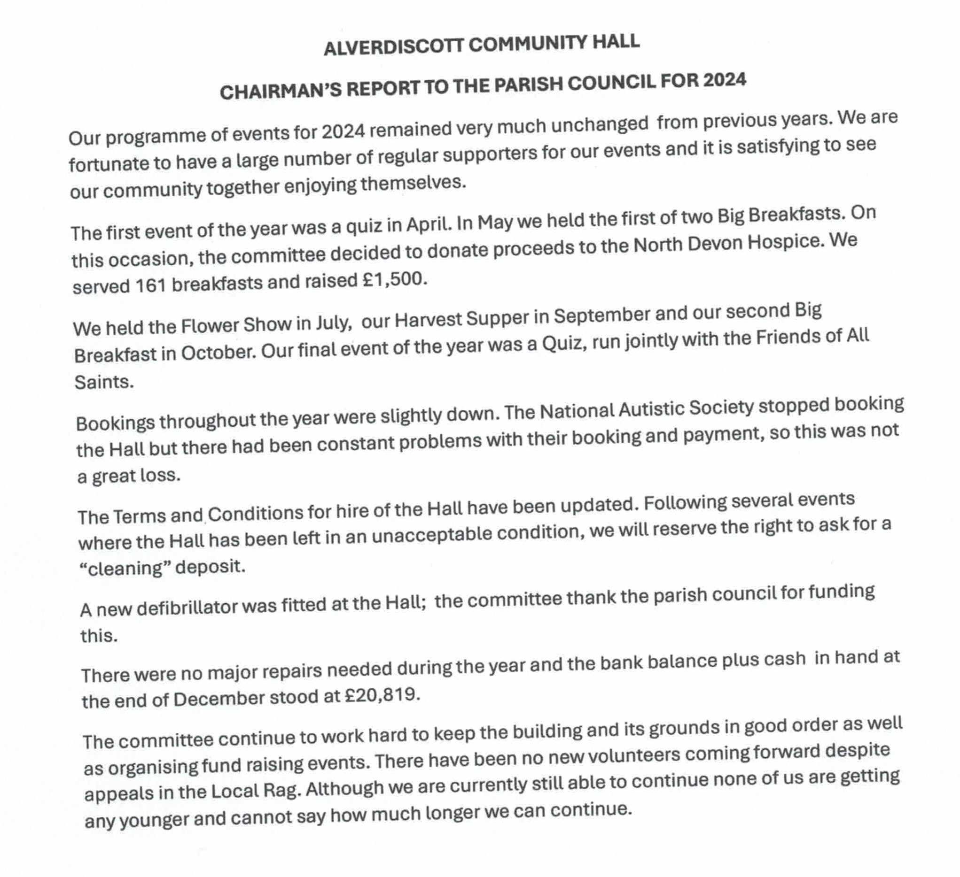

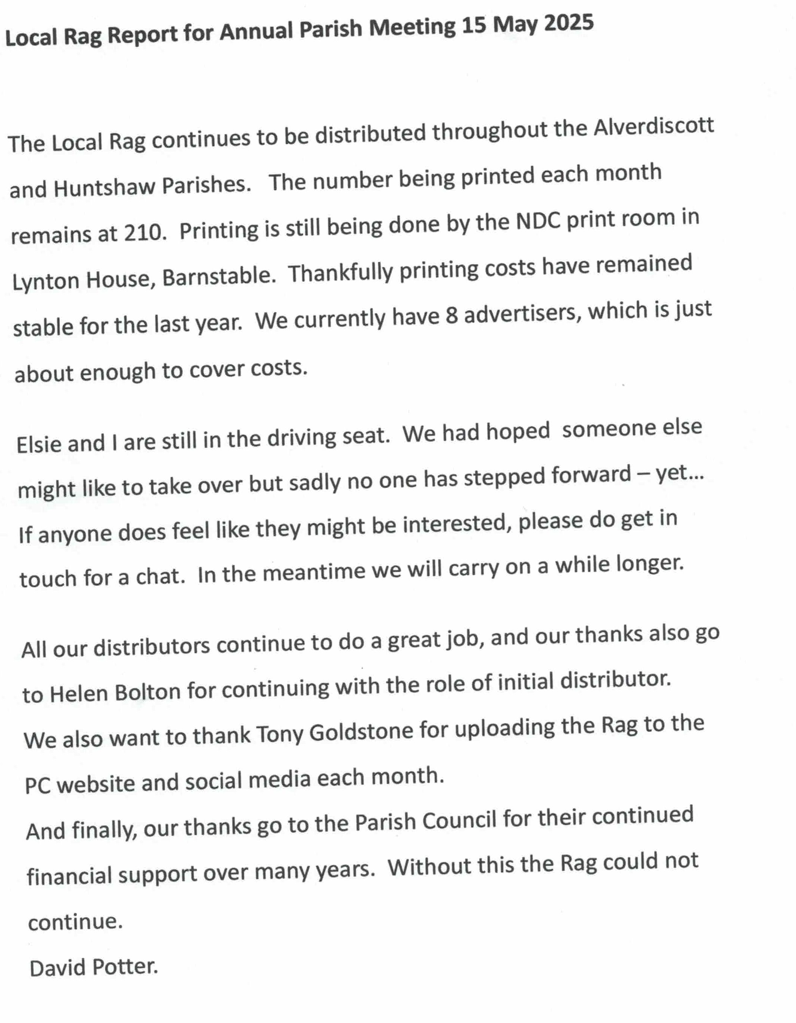

Appendix C:

Huntshaw Parish Hall 2024 Report
I would firstly like to thank the parish council for their continued support.
It was a busy year for the committee starting in April with our first Village Breakfast. This went very well, although it was a steep learning curve for us. We weren’t put off however, and made a few tweaks and held another one in November.
In July we had a Treasure hunt and BBQ. It was a very pleasant event for all those who came.
September saw the Harvest supper and then In October we held a Pub games and Race night.
A new skittle alley was purchased and we had skittles evenings in November and December. The skittles evenings have continued into 2025.
We are looking to celebrate the centenary of the Hall in 2025, and intend to complete the refurbishments to the Hall and to celebrate the centenary in June.

